Web Application Security Assessment

_______________________________________________

On-demand security penetration test of;
A server-based application
11 November – 5 December

_______________________________________________

Table of Contents

Section Name | Page #

1 Executive Summary: XXXXXXXXX – Effective Thinking 3
1.1 Target Description 3
1.2 Application Status 3
1.3 Security Test Summary 3
1.4 Summary of Findings 3
2 Security Test: IdentiKit 4
2.1 Introduction 4
2.2 Objectives and Scope 4
2.3 Test Criteria 5
2.3.1 Application(s) tested 5
2.3.2 Dates within which testing took place 5
2.3.3 IP Ranges attempted 5
2.4 Detailed Findings and Recommendations 6
2.5 Ranking Risks 6
2.6 Detailed Main Findings and Recommendations Matrix 8
Appendix A - Selected Findings 9

Executive Summary:

Target Description

Application Status
The application is owned by ???? and is currently in stage.

Security Test Summary
A security test of the ???? web application was performed between 11 November and 5 December 2025 inclusive.

The security tests were performed against a stage environment at the request of multimeds.ie as testing against the production environment was not permitted. As such any vulnerabilities are reported here without due consideration as to whether or not they exist in the corresponding production environment.
The testing concluded that there were 0 high-risk findings, 0 medium-risk finding and 0 low-risk finding(s) on the web site. The findings have been consolidated for this summary and additional information is contained within the detailed report.

Summary of Findings

- Finding 1 – Medium Risk (6/10)
One line description of each vulnerability here
- Finding 2 – Low Risk (3.9/10)
One line description of each vulnerability here
- Finding 3 – Low Risk (3.9/10)
One line description of each vulnerability here

Security Test: ???

Introduction
The intent is to assess these systems security vulnerabilities, which could lead to a compromise of confidential information or may otherwise damage reputation.
In general, the systems tested can include public facing web applications defenses.
The types of vulnerabilities identified are wide ranging, and can be “built-in” during design, build or support phases or can be caused by missing patch levels at the application server or operating system levels. The testing team can also identify security issues in the configuration of firewall and other network perimeter devices.
Once identified, the team will assess if further exploitation can safely provide any additional meaningful information or if the extent of the vulnerability has been established. In all cases the recommendations to identified vulnerabilities is provided so that the identified vulnerabilities can be fixed.
Assessments are usually conducted from the point of view of both an unauthorised attacker and also as an authorised malicious user who may be intent on either elevating their privileges, or attacking the application for other gain.

Objectives and Scope
The objective of this assignment was to perform controlled attack and penetration activities to assess the overall level of information privacy, integrity and security of the ???? web application.
The security test was conducted from the perspective of both an unauthorised attacker and also a malicious user.
These tests were conducted between 11 November and 5 December 2025 inclusive and the security tests have been conducted within the parameters signed-off in the Agreement of Criteria (outlined in section 2.3 – Test Criteria).
The security tests were performed against a stage. As such any vulnerabilities are reported here without due consideration as to whether or not they exist in the corresponding production environment.

Test Criteria
The following is the criteria that was assessed

Application(s) tested
 | URL |  | Environment |  | Owner
1 | https://localhost/Project |  | A test application on a stage server |  | Jamie Dempsey – C00295144

Dates within which testing took place
Date |  |  |  | Additional Information
From |  | To
11 November 2025 |  | 05 December 2025 |  | Network Scanning  Scanning tests will be conducted during the specified dates and times. These tests are used to establish the scope of the overall test. Scans to be conducted include;  • Application Scanning  • Port scanning of firewall(s)  • Identification of type  • Firewalking  • DNS interrogation  • DNS Zone Transfers
11 November 2025 |  | 05 December 2025 |  | Attack & Penetration  Attack and Penetration testing conducted during the specified dates and times.  This will include looking for specific vulnerabilities, including;  • Exploitation of HTTP  • Base64 Encoding  • Authentication Exploitation  • Direct Access Browsing  • Directory Traversal  • Writeable Web Directories  • Accessing Scripts Contents  • Exploitation of Hidden Tags  • Cookie Poisoning  • Cross-Site Scripting  • Parameter Tampering  • SQL Injection  • Brute Force Attack  • Session Replay Attack  • Session Hijacking  • Debug Mode / Comments Analysis and Exploitation
‘Denial of service’ attacks were NOT conducted within the criteria of this test.

IP Ranges attempted
From |  | To |  | Details
127.0.0.1 |  | 127.0.0.1 |  | localhost

Detailed Findings and Recommendations
The following section specifically illustrates the findings and recommendations that should be implemented to better secure and control the application. As with all recommendations that affect computer systems and production processing, these recommendations should be tested during non-production hours prior to their implementation. It is also prudent to have a full-system backup prior to implementing system changes.

Ranking Risks
The testing team initially ranks the vulnerabilities in turn to establish an overall threat perspective. This is done using a variation of the Microsoft D.R.E.A.D. formulation. Once the threat has been identified, the result is ranked as either a high, medium or low risk. This is based upon the risk they pose to _______ _____________. Please note that each of the vulnerabilities is ranked in isolation to determine whether the system would be vulnerable if other security measures and configurations were not in place. Reference the following tables for definitions of the risk ranking process:
Risk Rating | Threat
0.0 | Observation
0.1 - 4.0 | Low Risk
4.1 - 8.0 | Medium Risk
8.1 - 10.0 | High Risk

Score | 0 – 2 | 3 – 4 | 5 - 6 | 7 - 8 | 9 - 10
Damage Potential | Trivial information about the target disclosed. Trivial cost associated with impact | Significant information about the target architecture and/or application disclosed. Limited cost associated with impact | Extended or increased functional control of the application and/or underlying system. Moderate cost associated with impact | Full control of the application and/or the ability to view underlying network or database infrastructure. Large cost associated with impact | Full compromise of Network or Database Infrastructure. Extensive cost associated with impact
Reproducibility | Very difficult to reproduce (more than 24 hours) | Difficult to reproduce (within 24 hours) | Moderately difficult to reproduce (within 2 hours) | Easy to reproduce (within 5 minutes) | Very easy to reproduce (30 seconds or less)
Exploitability | Seasoned security skills and/or specialised tools required | Extensive skills and tools required | Moderate skills and tools required | limited skills and tools required | No skill or tools required
Affected Users | Very small limited user group (under 100) | Small user group (100 - 1,000) | Moderate user group (between 1,000 - 5,000) | Large user group (between 5,000 - 20,000) | Open to the general Internet with no authentication or very large group requiring authentication (20,000++)
Discoverability | Very difficult to find (over 24 hours) | Difficult to find (within 24 hours) | Moderate effort required to find (within 4 hours) | Easily found (within 2 hour) | Very easily found (within 1 hour)

Detailed Main Findings and Recommendations Matrix
The following matrix outlines the main findings from the testing that was conducted.
No | Finding / Description/ Impact | Recommendations for Improvement |  | D.R.E.A.D Threat Rating (out of 10)
No | Finding / Description/ Impact | Recommendations for Improvement |  | 40% | 5% | 10% | 40% | 5% | 100%
No | Finding / Description/ Impact | Recommendations for Improvement |  | Damage Potential | Reproducibility | Exploitability | Affected Users | Discoverability | D R E A D Total
 | File Inclusion – When the application loads a file based on user input, allowing an attacker to make the server display or execute internal files it shouldn’t expose.  The FileToView attribute in auth2.php loads files directly from the server without any validation. As shown in my findings, auth1.php is an internal file that, when supplied, displays the raw PHP source code to the user. This exposes database queries, session handling and other sensitive information. This vulnerability lets an attacker view any readable file on the server. Once they can do that, they can examine the website's source code, find passwords stored in configuration files, or read other sensitive files, such as logs. This could lead to account takeover or system compromise. | Validate input so only approved files can be loaded.  Block any file paths that are not distinctly allowed.  Don’t load files directly from user-controlled input.  Ensure raw PHP source code is never displayed.  If file paths are required, validate them with realpath() and prevent directory traversal. |  | 7 | 9 | 8 | 6 | 8 | 7.6 | M
 | Information Disclosure – Occurs when the application unintentionally reveals sensitive data such as source code, credentials, internal paths, or system details to the user.  This vulnerability is caused by the file inclusion flaw in auth2.php. By modifying the URL parameter FileToView, an attacker can load internal PHP files, including index.php. As shown in my findings, this exposes sensitive information such as SQL statements, application and database logic, file paths, and administrator account creation. By viewing the raw PHP source code, an attacker gains insight into how authentication, database resets and user management work, which puts the site at further risk of being compromised. | Validate input and restrict FileToView to a fixed rate.  Prevent raw PHP code from being displayed to users.  Move database reset logic away from accessible files.  Don’t expose file paths in any error or debug output. |  | 6 | 9 | 8 | 6 | 8 | 7.4 | M
 | Command Injection – Happens when user input is passed directly into a system command, allowing an attacker to execute harmful commands on the server.  The ping input field in auth1.php passes user-controlled data directly into a system command without any validation. As shown in my findings, once I entered the payload localhost & dir, the server executed the command and listed all files inside the directory. This exposes the server to a serious risk, as an attacker can use this vulnerability to read, modify or delete sensitive files, view the server's directory structure, create new users, download malicious tools or gain system information, which could result in a server takeover. | Validate input before using it in system commands.  Disable direct command execution where possible.  Allow only valid IP addresses to be entered.  Log and monitor unexpected input. |  | 10 | 9 | 8 | 8 | 7 | 8.4 | H
 | SQL Injection – Occurs when user input is inserted into a database query without filtering, enabling an attacker to modify the SQL query and access database data.  The login form is vulnerable to standard SQL Injection as unfiltered user input is sent directly into the SQL query used to authenticate users. When an invalid payload, such as Admin’ is submitted, the application returns a detailed SQL syntax error directly to the user. The error message confirms that the raw username is being executed inside the SQL query. Although this payload didn’t bypass authentication, the presence of an SQL syntax error proves that the system is executing unfiltered SQL input, which means an attacker could manipulate the logic and use other payloads to access, modify, or delete database data or escalate their privileges. | Reject characters in the username field, such as ‘/”/--  Use validation to restrict input to allowed patterns.  Treat user input as text to prevent SQL injection.  Hide database error messages from the users. |  | 6 | 10 | 8 | 3 | 9 | 7.2 | M
 | Blind SQL Injection – A variation of SQL Injection where the attacker can’t see the output directly, but can gain insight based on delays or changes to the application's overall behaviour.  The login form is vulnerable to Blind SQL Injection as user input is inserted into the SQL query without sanitisation. As shown in my findings below, when the payload admin’ OR SLEEP(5)-- is inserted into the username field, the page delays for approximately 5 seconds before returning the normal login failure message. This delay happens because the database executes the injected SLEEP() function. As the system is under a sleep illusion, where it is not responsive for 5 seconds, this could allow an attacker to extract database tables, usernames, password hashes, or even fully compromise the backend database. | Apply server-side input validation that rejects characters such as ‘/”/;/-- from being used.  Disable the user's ability to run SQL functions  Use prepared statements to ensure that whatever the user enters is treated as text and not as a command.  Ensure a consistent response time from the website. |  | 7 | 8 | 7 | 5 | 8 | 7.0 | M
 | XSS Stored – Where malicious user input is saved by the server and then later displayed to other users without any sanitisation. The attacker can store JavaScript code inside the database and have it executed once the page is run.  The login form is vulnerable to Stored Cross-Site Scripting (Stored XSS). As shown in my findings, once the payload User’ <div onpointerover=”alert(1)”>XSS Stored</div> is submitted as a username during login, the application stores the value and later displays it on the login events page without sanitising or encoding it. As the value is taken directly from the database and inserted into the HTML output, the attacker's code will execute whenever an admin views the page. This allows an attacker to run JavaScript in  a user’s browser, which can lead to credential or session theft, redirection, injection of new forms or phishing attacks. | Validate and sanitise user input before storing it.  Use HTTP to secure cookies to limit session theft.  Avoid displaying untrusted input in admin pages.  Disable HTML injection in the login fields. |  | 6 | 10 | 8 | 3 | 9 | 7.2 | M
 | XSS Reflective – This happens when user input is returned in the page response without any sanitisation. The browser treats the input as real HTML or JavaScript, so the attacker's script runs almost immediately.  The login form is vulnerable to Reflective Cross-Site Scripting (XSS). My findings show that when the payload <script>alert(1)</script> is entered into the username field of the login page, the application sends the string back into the HTTP response without sanitising it. As the browser sees the value as executable JavaScript, the script runs straight away in the user’s browser. This type of vulnerability can let an attacker steal session cookies, compromise accounts, alter page content or redirect users to other dangerous websites. | Use validation to block HTML and JavaScript tags.  Run user input through a function that disregards dangerous characters and turns it into plain text.  Don’t print user input without encoding it first. |  | 6 | 10 | 8 | 5 | 8 | 7.4 | M
 | CSRF – Cross-Site Request Forgery (CSRF) is an attack where a website accepts a user action without verifying that the user actually intended it. If the user is already logged in, an attacker can trick them into clicking a link that the browser will send the user’s session cookies to the attacker, causing repercussions like password changes.  The password change function in change.php is vulnerable to Cross-Site Request Forgery (CSRF). The application accepts password change requests through a modified URL, without checking whether the request was actually made by the user. After submitting a password change, the request appeared in ZAP, showing the GET request containing the old and new passwords. By modifying this URL in ZAP and entering it back into my browser, the server processed the request and updated the password in the database without any user confirmation. This vulnerability allows an attacker to lock users out of their accounts or even take over entirely. | Add a CSRF token to all change requests.  Validate CSRF tokens before accepting changes.  Use POST requests, not GET, for sensitive actions.  Block requests that don’t come from the same site.  Avoid placing sensitive parameters in the URL. |  | 9 | 10 | 9 | 8 | 7 | 8.6 | H
 | Nmap Scanning – This is a technique attackers use to map out the services, ports, and software versions that are running on a target system. By scanning the application with Nmap, an attacker can identify open ports, such as HTTP, HTTPS, and MySQL and what software is in use. This information helps an attacker plan further attacks.  The localhost server was scanned using Nmap, and the scan exposed active services and revealed multiple open ports such as Apache, HTTPD, HTTPS, MySQL and SSDP. This information allows an attacker to create a map of the system, identify the attack surface, and find vulnerable components. Although there was no direct exploit, exposing ports and revealing services gives an attacker a stronger chance of breaching the system. This vulnerability allows attackers to exploit outdated software or perform database attacks. | Disable any services that are not required.  Keep Apache, PHP, OpenSSL and MySQL updated.  Enable firewall rules to avoid Nmap execution  Monitor logs for unusual Nmap scanning.  Restrict access to internal services. |  | 5 | 10 | 8 | 3 | 9 | 7.0 | M

- Selected Findings
Date | Attack | Result
28/Nov/2025 | File Inclusion  HTTP Type: GET  Location: auth2.php  Vulnerable Parameter: FileToView  Payload: FileToView=auth1.php | 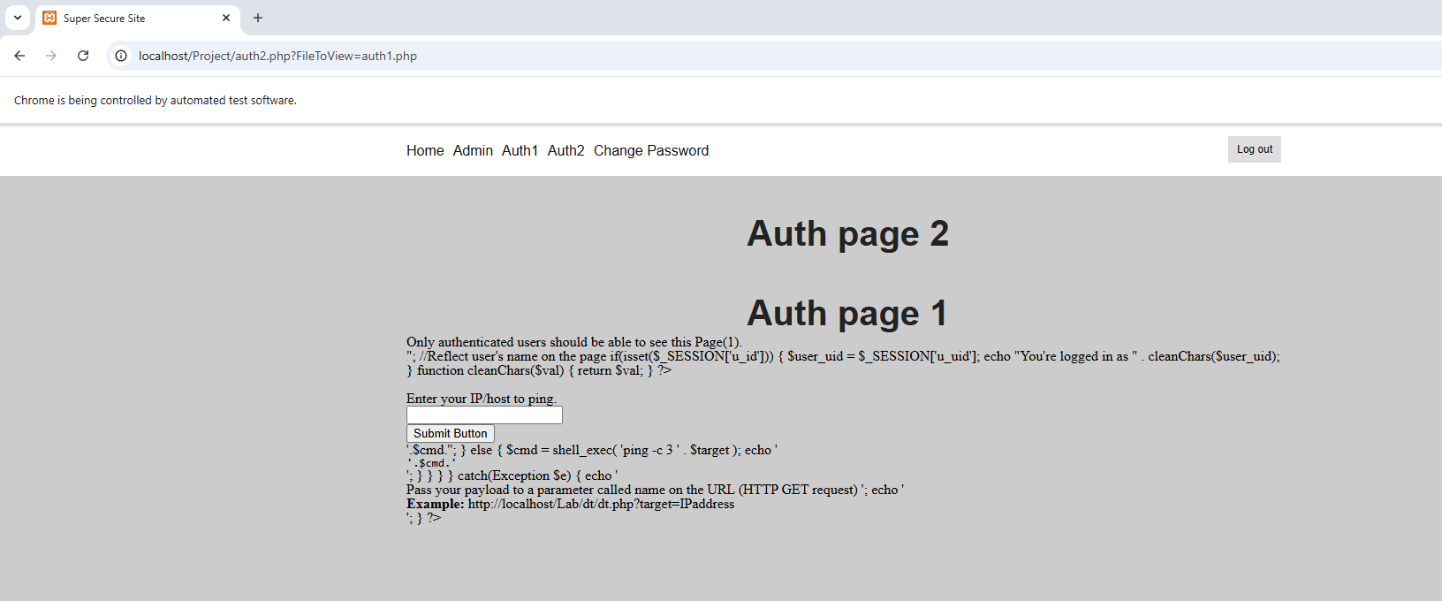
24/Nov/2025 | Information Disclosure  HTTP Type: GET  Location: auth2.php  Vulnerable Parameter: FileToView  Payload: FileToView=index.php | 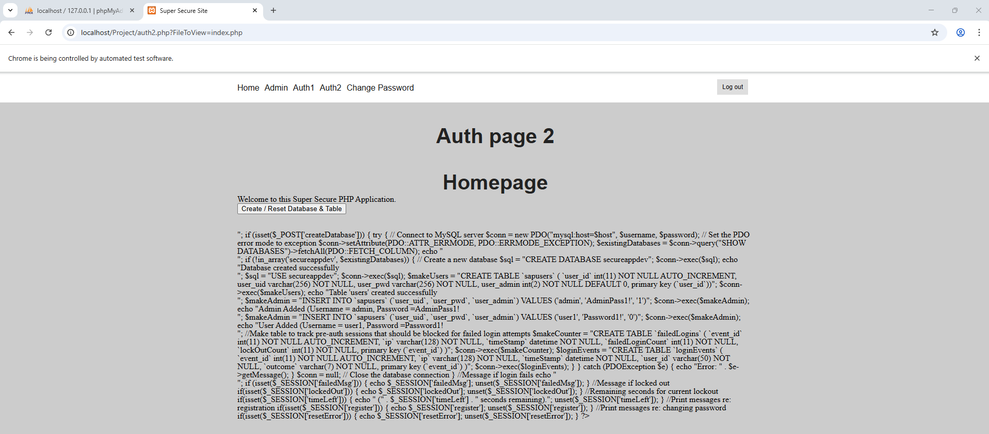
28/Nov/2025 | Command Injection  HTTP Type: POST  Location: auth1.php  Vulnerable Parameter: target ping  Payload: localhost & dir | 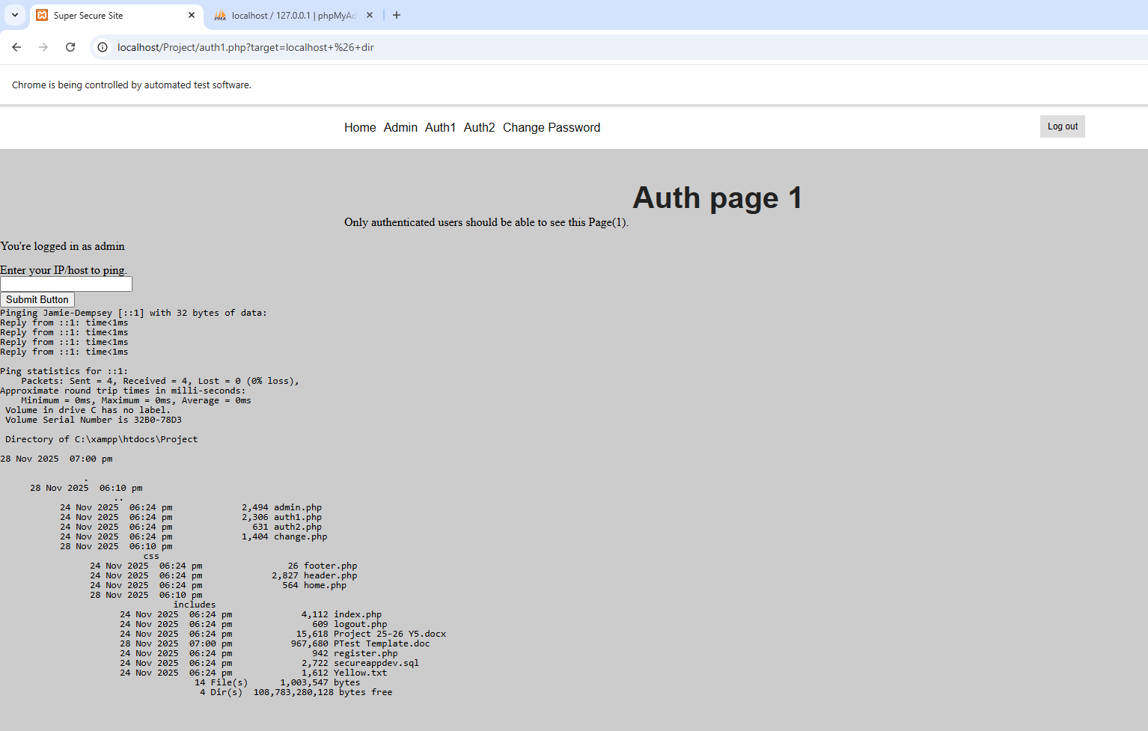
28/Nov/2025 | SQL Injection  HTTP Type: POST  Location: login.inc.php / index.php  Vulnerable Parameter: uid (username)  Payload: admin’ | 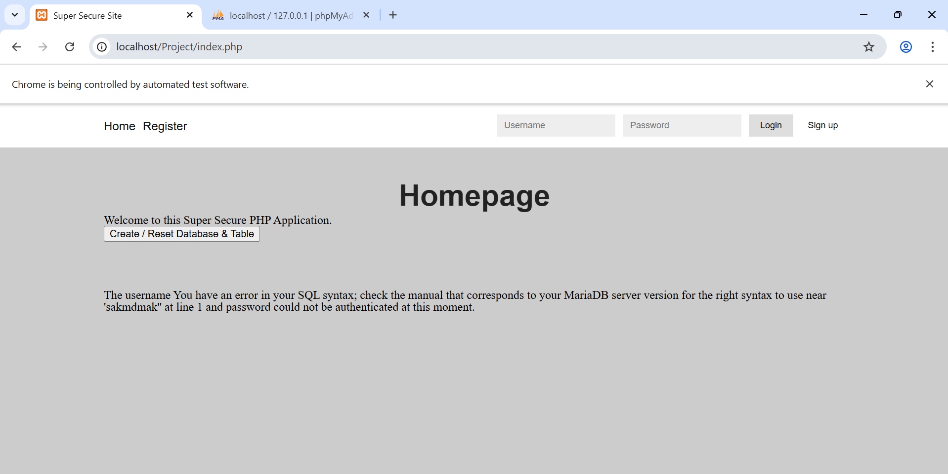
25/Nov/2025 | Blind SQL Injection  HTTP Type: POST  Location: login.inc.php / index.php  Vulnerable Parameter: uid (username)  Payload: admin' OR SLEEP(5)-- | 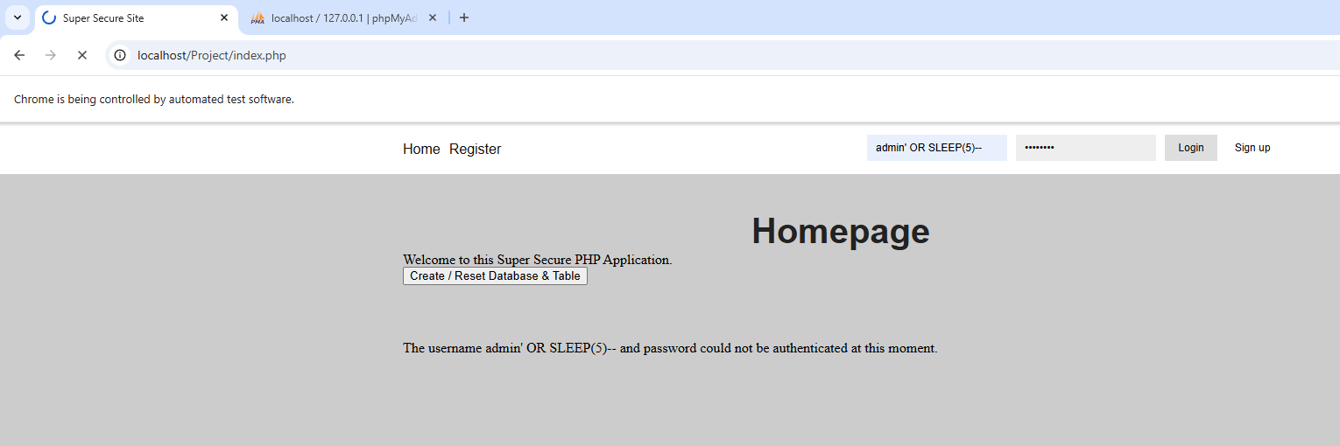
28/Nov/2025 | (Stored) XSS  HTTP Type: POST  Location: login.inc.php / index.php  Vulnerable Parameter: uid (username stored in database and then shown in admin log page)  Payload: User' <div onpointerover="alert(1)">XSS Stored</div> | 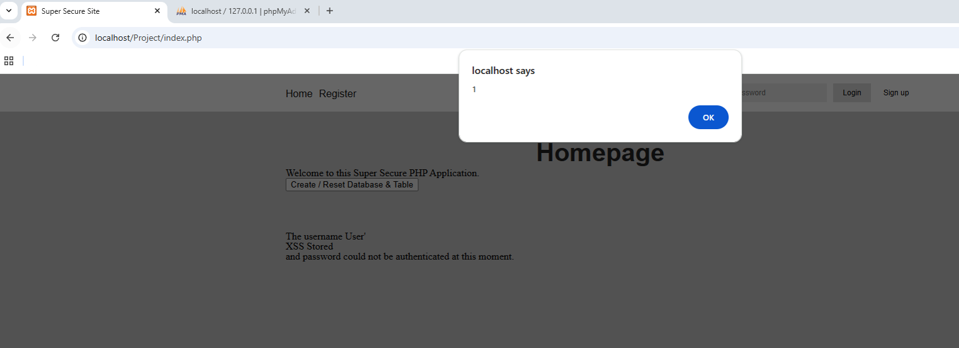  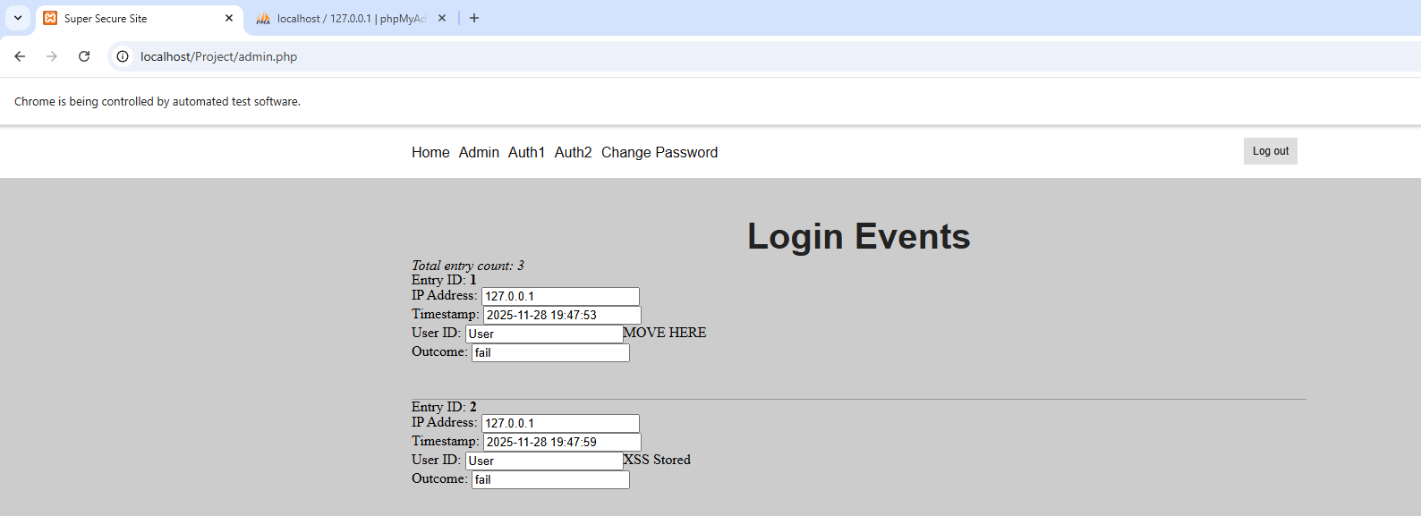
25/Nov/2025 | (Reflective) XSS  HTTP Type: POST  Location: index.php  Vulnerable Parameter: uid (username)  Payload: <script>alert(1)</script> | 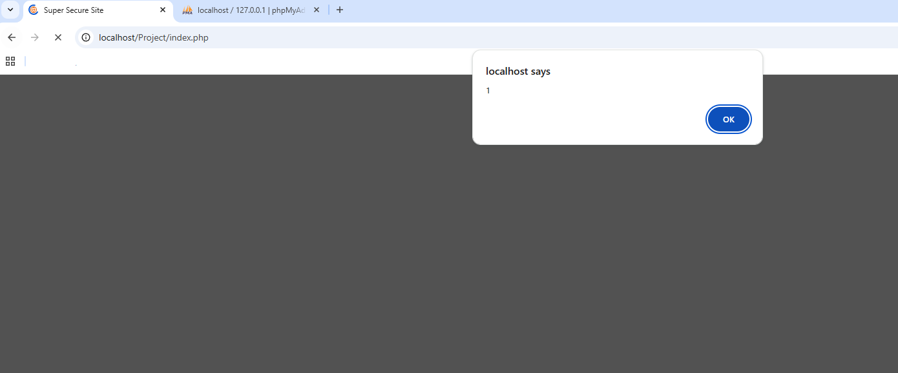
25/Nov/2025 | CSRF  HTTP Type: GET  Location: reset.inc.php  Vulnerable Parameter: user_pwd  Payload: URL from ZAP http://localhost/Project/includes/reset.inc.php?old=AdminPass1%21&new=AdminPass2%21&new_confirm=AdminPass2%21&reset=yes&csrf-token=a44e71f1f5f48425db19fbf8733321dbf3f9d38fe8dd98f82c4a9f9249e5a402 | 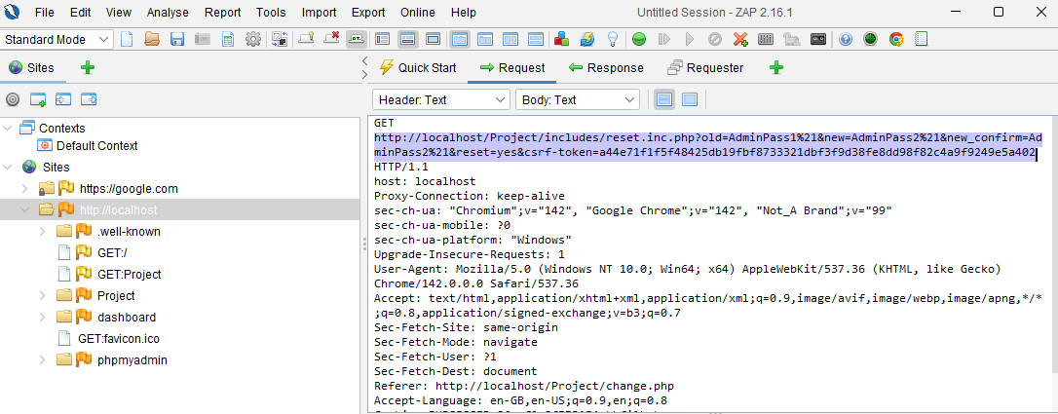  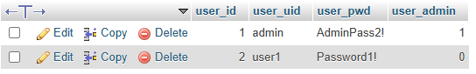  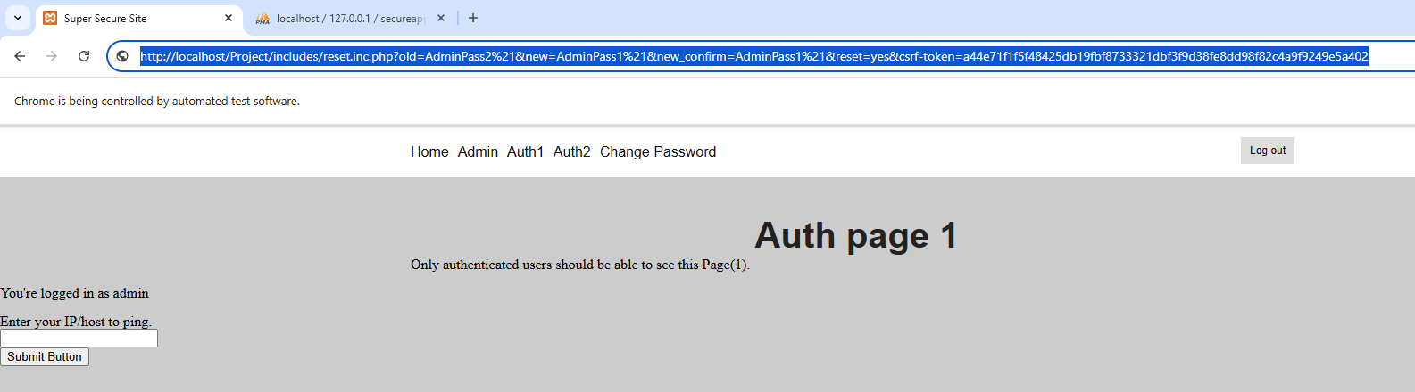
24/Nov/2025 | Nmap Scanning  HTTP Type: N/A (External tool)  Location: terminal / localhost (127.0.0.1)  Vulnerable Parameter: Exposed ports & services  Payload:  nmap localhost  nmap -sV localhost  nmap -A localhost | 